Digikey Crawler v2 Set Up Instruction

1. On Windows Search box, search Powershell and run Powershell as administrator:

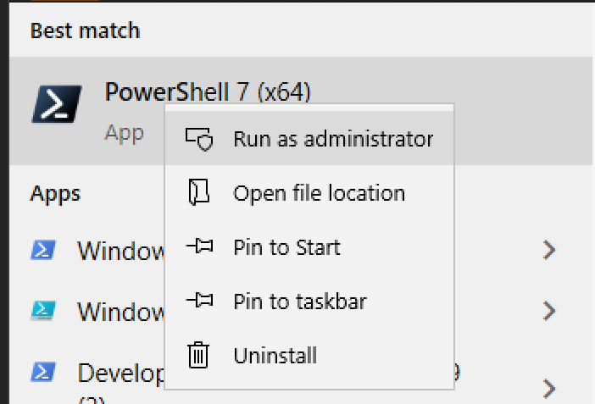

1. Select a folder path to clone the repository. Create the folder if necessary.

Such as “C:\python-projects”



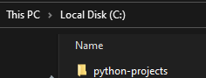

1. On Powershell, change directory to the selected path.

Type cd “C:\python-projects” and hit enter.

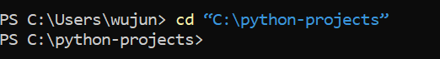

1. Clone the repository with git.

git clone <https://github.com/nchannelmosfet/DKCrawlerV2.git>

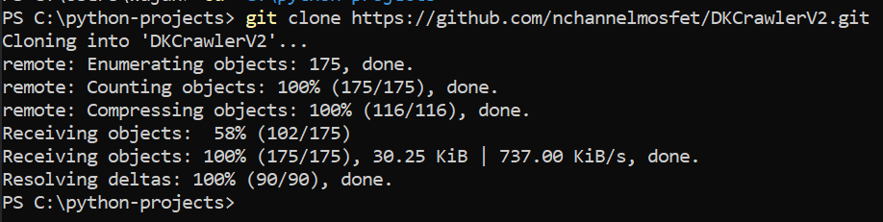

1. Change directory to the repository

cd DKCrawlerV2



1. Run the install.ps1 script to install virtual environment and packages

.\install.ps1

1. Configure project as PyCharm Project

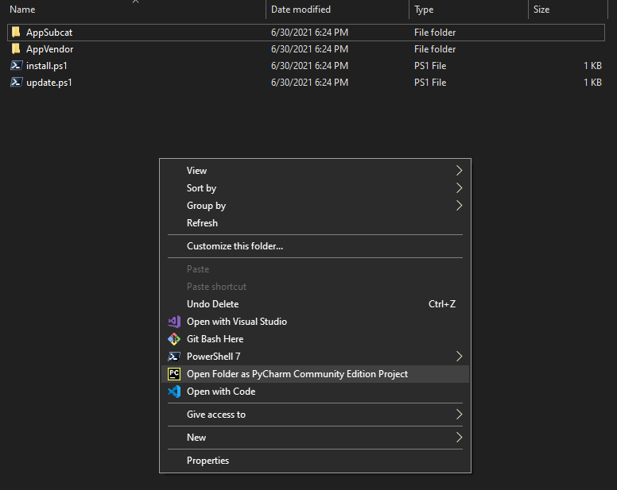

1. You can run update.ps1 to get future updates.

BE WARN! DON’T put any files you don’t wish to lose in the repository folder.

Running update.ps1 restore the repository to the previous state and pull the latest update from the remote repository. During this process, files or data may be lost.